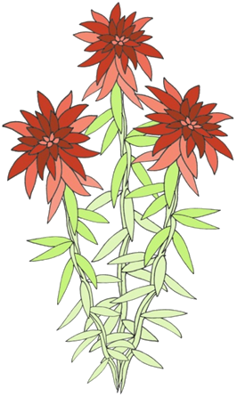
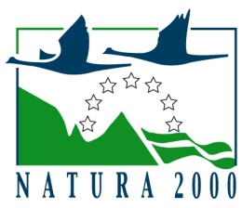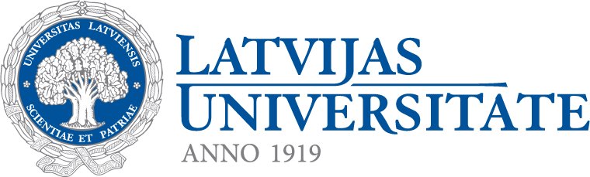
“Sharing experience on raised bog restoration”
July 22-25, 2012, Latvia
Seminar and field excursion

REGISTRATION FORM
Please complete the form and send by e-mail to daiga.brakmane@lu.lv before March 31st, 2012.
First (Given) name:
Middle name:
Family name:
Organization:
Postal address:
Tel: (country code - area code - tel no)
E-mail address:

Presentation:

Oral
Poster
None

I wish to participate in:

Excursion and seminar in Riga on July 23, 2012
Excursion to Aklais and Aizkraukle Mire on July 24, 2012
Excursion to Rožu Mire on July 25, 2012

Special dietary requirements:

Vegetarian
Special, please specify

Arrival and departure (if known: date, place and time):

Arrival
Departure

